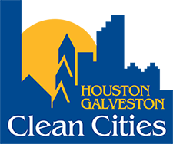
Houston-Galveston Clean Cities Stakeholder Meeting
Thursday, August 10, 2021
9:30 AM to 11:00 AM

- Introductions – Chris George, HGCCC Chair

- Alternative Fuel Activities at City of Houston – Gary Glasscock, City of Houston

- H-GAC Clean Vehicles and Buy America – Gilbert Washington, HGCCC

- Current Funding Announcements and Updates – Gilbert Washington, HGCCC

- Announcements of Current & Upcoming Activities

- Adjourn meeting

